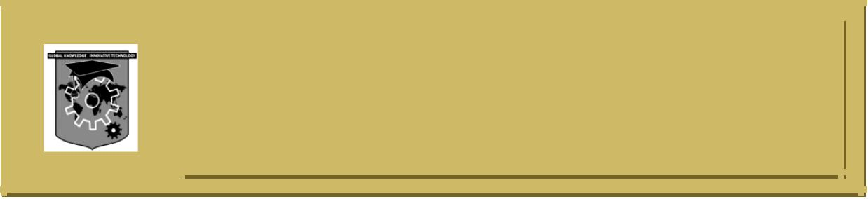**ACS COLLEGE OF ENGINEERINGC:\Documents and Settings\Administrator\Desktop\update kk\New Folder\naac-a-new.png**

**#207, Kambipura, Mysore road, Banglore-74**

**Department of Computer Science & Engineering**

**MODULE -1**

**INTRODUCATION TO OPERATING SYSTEMS, SYSTEM STRUCTURES**

1. Define Operating System. With a neat diagram, explain the dual-mode operation of operating system.
2. Explain the services of operating system that are helpful for user and the system.
3. Define the following terms:

i) Virtual Machine

ii) CPU Scheduler

iii) System call

iv) Context switch

1. What is a process? With a neat diagram, explain the different states of a process and clearly give the conditions for a process to shift from one state to another.
2. Explain the layered approach of operating system structure, with supporting diagram.
3. What is interprocess communication? Explain direct and indirect communication with respect to message passing system.
4. What are virtual machines? Explain with block diagram. Give its implementation and benefits
5. Explain VM-WARE architecture with a neat diagram.
6. What are the merits of inter process communication? Name the two major models of inter process communication.
7. What are the different categories of system program? Explain.
8. With neat diagram, explain componenets of PCB.
9. Differentiate between multiprogramming, multiprocessing and multitasking systems.
10. What are system calls? Briefly point out its types.